1. Complete the following table.
Formula of  particle | Atomic  number | Mass  number | Protons | Neutrons | Electrons | Electron arrangement  of particle
²⁴Mg
³⁵Cl⁻
²⁷Al³⁺
¹⁹F⁻
⁴⁰Ca²⁺
¹⁴N
(6 marks)
2.
(a) Table 1 gives some information about three subatomic particles.
(i) Complete Table 1 by giving the missing information. (3 marks)
Subatomic particle | Relative mass | Relative charge
Electron
Proton
Neutron
(ii) Give the name of the part of the atom containing protons and neutrons. (1 mark)
________________________________________________________________________
(b) Table 2 shows the numbers of protons, neutrons and electrons in the species P, Q, R, S, T and U.
Species | Number of protons | Number of neutrons | Number of electrons
P | 8 | 8 | 8
Q | 9 | 10 | 10
R | 12 | 12 | 10
S | 12 | 13 | 12
T | 17 | 18 | 17
U | 17 | 20 | 17
Use the information in Table 2 to answer these questions. Each species may be used once, more than once or not at all.
- Give the letter of the species that is a negative ion. (1 mark)
________________________________________________________________________
- Give the mass number of S. (1 mark)
________________________________________________________________________
- Give the letter of the species that is a positive ion. (1 mark)
________________________________________________________________________
- Give the letters of the two species that are isotopes of the same element. (1 mark)
________________________________________________________________________
(c) A sample of chlorine contains two isotopes, ³⁵Cl and ³⁷Cl.
(i) State ONE difference between ³⁵Cl and ³⁷Cl. (1 mark)
________________________________________________________________________
________________________________________________________________________
(ii) Explain why ³⁵Cl and ³⁷Cl have the SAME chemical properties. (1 mark)
________________________________________________________________________
________________________________________________________________________
3. The table shows the number of protons, neutrons and electrons in species A, B, C, D and E.
 | Number of protons | Number of neutrons | Number of electrons
A | 1 | 0 | 1
B | 3 | 4 | 3
C | 3 | 4 | 2
D | 8 | 8 | 8
E | 8 | 10 | 8
- Which species is an ion of lithium? (1 mark)
________________________________________________________________________
- Which two species are isotopes? (1 mark)
________________________________________________________________________
- Give the electronic arrangement of species D. (1 mark)
________________________________________________________________________
- Give the FULL atomic symbol of species B. (1 mark)
________________________________________________________________________
- Explain, with reference to numbers of subatomic particles, why species A is electrically neutral. (1 mark)
________________________________________________________________________
________________________________________________________________________
4. Ions can be formed when an atom gains or loses electrons.
(a) Complete the following table. Assume all ions attains the electronic arrangement of the nearest noble gas.
Particle | Atomic  number | Mass  number | Proton | Neutron | Electron | Electronic  arrangement
Sodium atom | 11 | 23
Sodium ion |  | 23
Sulphur atom |  | 32 | 16
Sulphide ion
Aluminium atom | 13 |  |  | 14
Aluminium ion |  | 27
(6 marks)
(b) Atoms tend to attain the electronic arrangement of the nearest noble gas. State the charge of the stable ion formed by an atom of Group VI. (1 mark)
________________________________________________________________________
5.Draw the electron diagram for each of the following species.
(a) O atom (1 mark)

(b) Stable ion formed by O atom (1 mark)

(c) Ca atom (1 mark)

(d) Stable ion formed by Ca atom (1 mark)

(e) N atom (1 mark)

(f) Stable ion formed by N atom (1 mark)

6. Metals can react with non-metals to give ionic compounds.
(a) What is ionic bond? (1 mark)
________________________________________________________________________
________________________________________________________________________
________________________________________________________________________
(b) When sodium reacts with sulphur, sodium sulphide is formed.
(i) State the electron arrangement of the following ions. (0 marks
(1) Sodium ion (1 mark)
________________________________________________________________________
(2) Sulphide ion (1 mark)
________________________________________________________________________
(ii) Write down the chemical formula of sodium sulphide. (1 mark)
________________________________________________________________________
(iii) Draw the electron diagram of sodium sulphide, showing electrons in the outermost shells only. (1 mark)

(c) When calcium reacts with nitrogen, calcium nitride is formed.
(i) State the electron arrangement of the following ions.
(1) Calcium ion (1 mark)
________________________________________________________________________
(2) Nitride ion (1 mark)
________________________________________________________________________
(ii) Write down the chemical formula of calcium nitride. (1 mark)
________________________________________________________________________
(iii) Draw the electron diagram of calcium nitride, showing electrons in the outermost shells only. (1 mark)

7. Chlorine occurs naturally in two stable isotopes, ³⁵Cl and ³⁷Cl. The abundance of ³⁵Cl is 75.8%.
(a) What is meant by the term ‘isotope’? (1 mark)
________________________________________________________________________
________________________________________________________________________
(b) Calculate the relative atomic mass of Cl. (2 marks)
________________________________________________________________________
________________________________________________________________________
________________________________________________________________________
(c) On the ¹²C = 12.00 scale, state what the relative isotopic mass of an isotope is roughly equal to. (1 mark)
________________________________________________________________________
________________________________________________________________________
(d) Can ³⁵Cl and ³⁷Cl be separated by chemical methods? Explain your answer. (2 marks)
________________________________________________________________________
________________________________________________________________________
________________________________________________________________________
8. Complete the following table.
 | Chemical name | Chemical formula
(a) | Potassium bromide
(b) | Magnesium oxide
(c) | Iron(III) chloride
(d) | Aluminium oxide
(e) | Calcium carbonate
(f) | Ammonium sulphate
(g) | Sodium hydroxide
(h) | Copper(II) sulphate
(8 marks)

9. Give full names of the following ionic compounds.
 | Chemical formulae | Chemical name
(a) | FeCl₂
(b) | CuSO₄
(c) | Na₂S
(d) | AgBr
(e) | KNO₂
(f) | CaSO₄
(g) | (NH₄)₂CO₃
(h) | Zn(NO₃)₂
(8 marks)
10. Complete the table below by filling in the name and colour of the aqueous solution of each compound.
Formula of compound | Name of compound | Color of its aqueous solution
KMnO₄
Cu(NO₃)₂
FeCl₃
FeSO₄
K₂CrO₄
K₂Cr₂O₇
CoCl₂
NiSO₄
(8 marks)

11. The table gives the formulae of some positive and negative ions.
 | Cl⁻ | O²⁻ | N³⁻
Na⁺ | Compound A | Compound B | Compound C
Mg²⁺ | Compound D | Compound E | Compound F
Al³⁺ | Compound G | Compound H | Compound I
- Write the chemical formulae of compounds A to I. (9 marks)
________________________________________________________________________
________________________________________________________________________
________________________________________________________________________
________________________________________________________________________
________________________________________________________________________
- State ONE property of substances with giant ionic structure related to electrical conductivity. (1 mark)
________________________________________________________________________
________________________________________________________________________
________________________________________________________________________
12. The incomplete diagram below shows the experimental set-up of investigating the migration of colored ion.
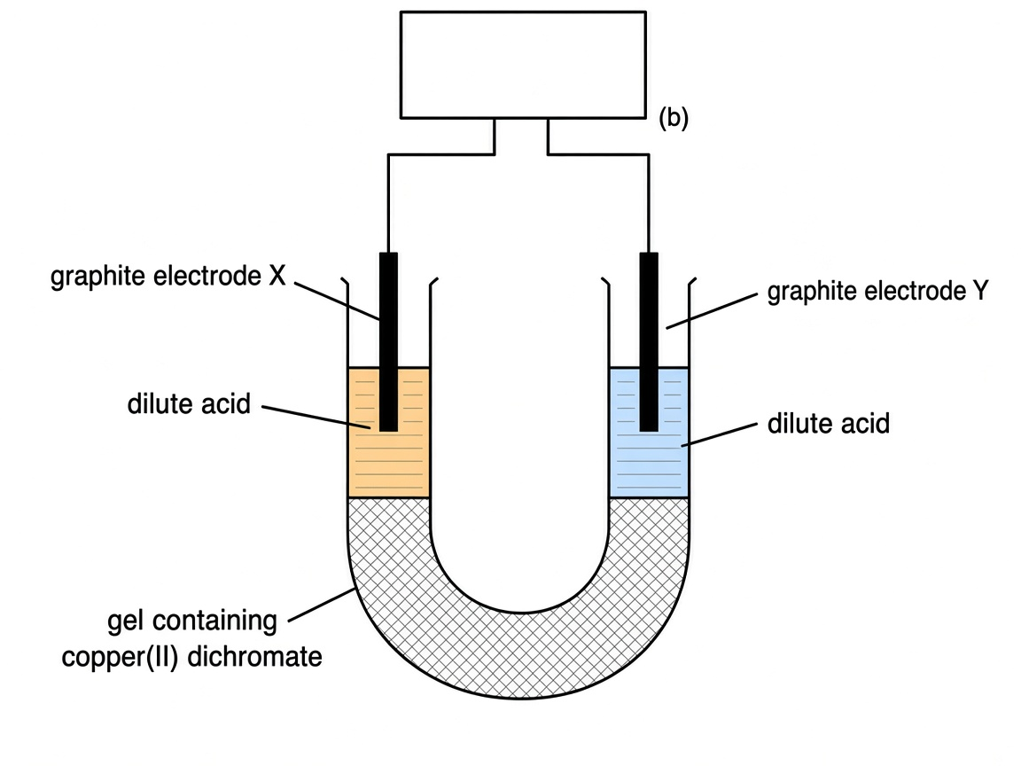

After the electric current has passed for 10 minutes, it was found that blue color gradually appears in the solution around electrode Y.
- Write the chemical formula of copper(II) dichromate. (1 mark)
________________________________________________________________________
- Complete the diagram by drawing the power supply and indicating the direction of electron flow in the provided box. (1 mark)
- What will be observed in electrode X? Explain your answer. (2 marks)
________________________________________________________________________
________________________________________________________________________
________________________________________________________________________
- Explain why the migration of colored ions CANNOT be observed if copper(II) dichromate is replaced by calcium chloride. (1 mark)
________________________________________________________________________
________________________________________________________________________
- What will be the difference in observation if copper(II) dichromate is replaced by potassium permanganate in the above set-up? (2 marks)
________________________________________________________________________
________________________________________________________________________
________________________________________________________________________
- Why is a gel containing copper(II) dichromate, rather than an aqueous solution of the compound, used in this experiment? (2 marks)
________________________________________________________________________
________________________________________________________________________
________________________________________________________________________
13. The set-up shown in the diagram below is used to study the migration of ions.
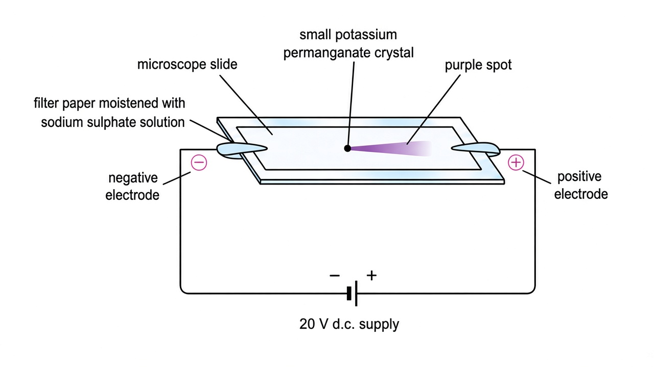
After the circuit is closed for some time, a purple spot is found moving towards one of the poles.
- Towards which pole (positive or negative) does the purple spot move? Explain your answer. (2 marks)
________________________________________________________________________
________________________________________________________________________
________________________________________________________________________
- State the purpose of moistening the filter paper with dilute sodium sulphate solution. (1 mark)
________________________________________________________________________
________________________________________________________________________
- What would be observed if the paper is not connected to the d.c. supply? (1 mark)
________________________________________________________________________
________________________________________________________________________
- Suggest ONE way to speed up the experiment. (1 mark)
________________________________________________________________________

14. When potassium burns in oxygen, potassium oxide is produced.
(a) With the help of a simple diagram, describe the bonding in potassium metal. (2 marks)

- What is metallic bond? (1 mark)
________________________________________________________________________
________________________________________________________________________
- Explain why potassium metal is a good conductor of electricity. (1 mark)
________________________________________________________________________
________________________________________________________________________
- Draw the electron diagram of potassium oxide, showing electrons in the outermost shells only. (1 mark)

- Explain why ionic compounds do not conduct electricity in solid state. (1 mark)
________________________________________________________________________
________________________________________________________________________

15. Strontium (Sr) and calcium (Ca) are elements in Group II of the periodic table.
(a) What is the name commonly given to this group of elements? (1 mark)
________________________________________________________________________
(b) State the electronic arrangement of a calcium atom and a calcium ion. (2 marks)
________________________________________________________________________
________________________________________________________________________
- Write the word equation for the reaction between calcium and water. (1 mark)
________________________________________________________________________
________________________________________________________________________
- Predict whether strontium or calcium has a higher reactivity towards water. Explain your answer. (2 marks)
________________________________________________________________________
________________________________________________________________________
________________________________________________________________________
- Write the chemical formula of strontium chloride. (1 mark)
________________________________________________________________________

Answer
1.
Formula of particle | Atomic number | Mass number | Protons | Neutrons | Electrons | Electron arrangement of particle
²⁴Mg | 12 | 24 | 12 | 12 | 12 | 2,8,2
³⁵Cl⁻ | 17 | 35 | 17 | 18 | 18 | 2,8,8
²⁷Al³⁺ | 13 | 27 | 13 | 14 | 10 | 2,8
¹⁹F⁻ | 9 | 19 | 9 | 10 | 10 | 2,8
⁴⁰Ca²⁺ | 20 | 40 | 20 | 20 | 18 | 2,8,8
¹⁴N | 7 | 14 | 7 | 7 | 7 | 2,5
Atomic number (No. of protons); electronic arrangements from atom table / ion octet or duplet.
Source: topic-02-microscopic-world-i.pdf p.1 Atomic symbol table; p.6 Charge of stable ion
2.
(a) (i) Electron: Relative mass Negligible / 0.0005; Charge −1. Proton: Relative mass 1; Charge +1. Neutron: Relative mass 1; Charge 0.
Source: p.1 Subatomic particle table (Relative mass: 1, 1, Negligible; Charge: +1, 0, −1)
(a) (ii) Nucleus
Source: p.1 Position: Nucleus (Proton, Neutron)
(b) (i) Q
Source: from Table 2 — electrons > protons
(b) (ii) 25 (12 + 13)
Source: from Table 2
(b) (iii) R
Source: from Table 2 — protons > electrons
(b) (iv) T and U — Isotopes are atoms of the element with same number of protons but different number of neutrons
Source: p.2 Isotopes
(c) (i) Different number of neutrons / different mass number / different relative isotopic mass (any ONE difference consistent with isotopes).
Source: p.2 Isotopes
(c) (ii) Isotopes have SAME chemical properties (NOT SIMILAR) because they are atoms with same electronic arrangement.
Source: p.2 Note
3.
(a) C
Source: Li atom B has 3 protons, 3 electrons; C has 3 protons, 2 electrons → Li⁺
(b) D and E — Isotopes are atoms of the element with same number of protons but different number of neutrons
Source: p.2 Isotopes
(c) 2,6
Source: p.1 Oxygen* O 2,6
(d) ⁷₃Li / ⁷Li (3 protons, 4 neutrons)
Source: p.1 Lithium# Li
(e) Atoms are electrically neutral because the number of positively charged protons is equal to the number of negatively charged electrons.
Source: p.1 Note 3
4.
Particle | Atomic number | Mass number | Proton | Neutron | Electron | Electronic arrangement
Sodium atom | 11 | 23 | 11 | 12 | 11 | 2,8,1
Sodium ion | 11 | 23 | 11 | 12 | 10 | 2,8
Sulphur atom | 16 | 32 | 16 | 16 | 16 | 2,8,6
Sulphide ion | 16 | 32 | 16 | 16 | 18 | 2,8,8
Aluminium atom | 13 | 27 | 13 | 14 | 13 | 2,8,3
Aluminium ion | 13 | 27 | 13 | 14 | 10 | 2,8
(a) as in completed table.
Source: p.1 Sodium# Na 2,8,1; Sulphur* S 2,8,6; Aluminium# Al 2,8,3; p.6 Charge of stable ion Group I +, VI 2–, III 3+
(b) 2–
Source: p.6 Charge of stable ion — Group VI: 2–
5.
(a) Electron diagram of O atom — electronic arrangement 2,6
Source: p.1 Oxygen* O 2,6
(b) Electron diagram of O²⁻ — electronic arrangement 2,8; In most cases, cations do not have outermost shell electrons while anions have 8 outermost shell electrons (except H⁻)
Source: p.6 Step 3; Charge of stable ion Group VI 2–
(c) Electron diagram of Ca atom — electronic arrangement 2,8,8,2
Source: p.1 Calcium# Ca 2,8,8,2
(d) Electron diagram of Ca²⁺ — electronic arrangement 2,8,8; cations do not have outermost shell electrons
Source: p.6 Charge of stable ion Group II 2+; Step 3
(e) Electron diagram of N atom — electronic arrangement 2,5
Source: p.1 Nitrogen* N 2,5
(f) Electron diagram of N³⁻ — electronic arrangement 2,8; anions have 8 outermost shell electrons
Source: p.6 Charge of stable ion Group V 3–; Step 3; Example 1: N → N³–
6.
(a) Ionic bond is a strong, non-directional electrostatic attraction between oppositely charged ions. It is formed by the transfer of one or more electrons from one atom to another
Source: p.6 Ionic bond
(b) (i) (1) 2,8
Source: p.1 Sodium# Na 2,8,1 → Na⁺; p.6
(b) (i) (2) 2,8,8
Source: p.1 Sulphur* S 2,8,6 → S²⁻; p.6
(b) (ii) Na₂S
Source: p.6 Example pattern; Chemical formula from ion charges Group I + and Group VI 2–
(b) (iii) Electron diagram of Na₂S: two Na⁺ (no outermost shell electrons shown) and one S²⁻ with 8 outermost shell electrons
Source: p.6 Steps for drawing electron diagrams of ionic compounds
(c) (i) (1) 2,8,8
Source: p.1 Calcium# Ca 2,8,8,2 → Ca²⁺
(c) (i) (2) 2,8
Source: p.1 Nitrogen* N 2,5 → N³⁻
(c) (ii) Ca₃N₂
Source: p.6 Charge of stable ion Group II 2+, Group V 3–
(c) (iii) Electron diagram of Ca₃N₂: three Ca²⁺ and two N³⁻ with 8 outermost shell electrons on each nitride ion
Source: p.6 Steps 1–4
7.
(a) Isotopes are atoms of the element with same number of protons but different number of neutrons
Source: p.2 Isotopes
(b) Note that the abundance of ³⁷Cl is 100% – 75.8% = 24.2%. R. A. M. = [(35)(75.8) + (37)(24.2)] / 100. R. A. M. = 35.484
Source: p.2 Example 1
(c) On the ¹²C = 12.00 scale, the relative isotopic mass of an isotope is roughly equal to its mass number. It carries no unit.
Source: p.2
(d) No. They CANNOT be separated by chemical methods. Isotopes have SAME chemical properties (NOT SIMILAR) because they are atoms with same electronic arrangement. They CAN be separated by physical methods.
Source: p.2 Note
8.
(a) KBr
Source: p.7 Bromide ion Br⁻; Potassium ion K⁺
(b) MgO
Source: p.7 Magnesium ion Mg²⁺; Oxide ion O²⁻
(c) FeCl₃
Source: p.7 Iron(III) ion Fe³⁺; Chloride ion Cl⁻
(d) Al₂O₃
Source: p.6 Chemical formula: Al₂O₃; Aluminium ion Al³⁺; Oxide ion O²⁻
(e) CaCO₃
Source: p.7 Calcium ion Ca²⁺; Carbonate ion CO₃²⁻
(f) (NH₄)₂SO₄
Source: p.7 Ammonium ion NH₄⁺; Sulphate ion SO₄²⁻
(g) NaOH
Source: p.7 Sodium ion Na⁺; Hydroxide ion OH⁻
(h) CuSO₄
Source: p.7 Copper(II) ion Cu²⁺; Sulphate ion SO₄²⁻
9.
(a) Iron(II) chloride
Source: p.7 Iron(II) ion Fe²⁺; Chloride ion Cl⁻
(b) Copper(II) sulphate
Source: p.7 Copper(II) ion Cu²⁺; Sulphate ion SO₄²⁻
(c) Sodium sulphide
Source: p.7 Sodium ion Na⁺; Sulphide ion S²⁻
(d) Silver bromide
Source: p.7 Silver ion Ag⁺; Bromide ion Br⁻
(e) Potassium nitrite
Source: p.7 Potassium ion K⁺; Nitrite ion NO₂⁻
(f) Calcium sulphate
Source: p.7 Calcium ion Ca²⁺; Sulphate ion SO₄²⁻
(g) Ammonium carbonate
Source: p.7 Ammonium ion NH₄⁺; Carbonate ion CO₃²⁻
(h) Zinc nitrate
Source: p.7 Zinc ion Zn²⁺; Nitrate ion NO₃⁻
10.
Formula of compound | Name of compound | Color of its aqueous solution
KMnO₄ | Potassium permanganate | Purple
Cu(NO₃)₂ | Copper(II) nitrate | Blue
FeCl₃ | Iron(III) chloride | Yellow
FeSO₄ | Iron(II) sulphate | Green
K₂CrO₄ | Potassium chromate | Yellow
K₂Cr₂O₇ | Potassium dichromate | Orange
CoCl₂ | Cobalt(II) chloride | Pink
NiSO₄ | Nickel(II) sulphate | Green
Colors from ion names: Permanganate ion (Purple); Copper(II) ion (Blue); Iron(III) ion (Yellow); Iron(II) ion (Green); Chromate ion (Yellow); Dichromate ion (Orange); Cobalt(II) ion (Pink); Nickel(II) ion (Green).
Source: p.7 Formulae and names of ions
11.
(a) A: NaCl; B: Na₂O; C: Na₃N; D: MgCl₂; E: MgO; F: Mg₃N₂; G: AlCl₃; H: Al₂O₃; I: AlN
Source: p.6 Steps 1–2; p.7 ion charges
(b) Conductor of electricity in aqueous state and molten state ➔ Due to the presence of mobile ions (Ions in solid state are NOT mobile. Therefore ionic compounds do not conduct electricity in solid state)
Source: p.13 Properties of substances with giant ionic structure
12.
(a) CuCr₂O₇
Source: p.7 Copper(II) ion Cu²⁺; Dichromate ion Cr₂O₇²⁻
(b) positive side on the left, negative side on the right, electron flow from left to right through the power supply.
(c) Orange / yellow-orange color around electrode X (positive pole). Dichromate ion Cr₂O₇²⁻ (Orange) is a colored anion and will be attracted by positive pole.
Source: p.7 Dichromate ion (Orange); p.8 Purple color should move towards positive pole because MnO₄⁻, a purple anion, will be attracted by positive pole (same principle for Cr₂O₇²⁻)
(d) Calcium ion and chloride ion are colorless / not colored ions; migration of colored ions cannot be observed.
Source: p.7 Ca²⁺ Calcium ion; Cl⁻ Chloride ion (no color stated); experiment observes colored ions
(e) Purple color should move towards positive pole because MnO₄⁻, a purple anion, will be attracted by positive pole. (No blue Cu²⁺ migration towards negative pole.)
Source: p.8 Experiment 1 Note; p.7 Permanganate ion (Purple)
(f) The gel can slow down the mixing of the bottom layer in the U-tube with the top layer. It also slows down the migration of Cu²⁺(aq) and Cr₂O₇²⁻(aq) ions to make the results more easily observed.
Source: p.8 Experiment 2
13.
(a) Positive pole. Purple color should move towards positive pole because MnO₄⁻, a purple anion, will be attracted by positive pole.
Source: p.8 Experiment 1 step 4
(b) Sodium sulphate solution can increase the electrical conductivity of the filter paper by providing mobile ions.
Source: p.8 Experiment 1 procedure 1
(c) If the paper is not connected to d.c. supply, the purple color patch will diffuse to all directions.
Source: p.8 Note 1
(d) To speed up the experiment, higher voltage can be applied.
Source: p.8 Note 2
14.
(a) All metals have giant metallic structure. Outermost shell electrons of metal atoms are delocalized. Giant lattice of positive metal ions are surrounded by a sea of delocalized electrons. (Diagram: K⁺ lattice + sea of delocalized electrons)
Source: p.12 Giant metallic structure
(b) Metallic bond is the strong, non-directional electrostatic attraction between the delocalized electrons and metal ions
Source: p.12
(c) Good conductor of heat and electricity ➔ Due to the presence of delocalized electrons
Source: p.12 Properties of substances with giant metallic structure
(d) Electron diagram of K₂O: two K⁺ and one O²⁻ with 8 outermost shell electrons on oxide ion. Chemical formula from K⁺ and O²⁻.
Source: p.6; p.7 Potassium ion K⁺; Oxide ion O²⁻
(e) Ions in solid state are NOT mobile. Therefore ionic compounds do not conduct electricity in solid state
Source: p.13 Properties of substances with giant ionic structure
15.
(a) Alkaline earth metals
Source: p.4 Group II: Alkaline earth metals
(b) Calcium atom: 2,8,8,2; Calcium ion: 2,8,8
Source: p.1 Calcium# Ca 2,8,8,2; p.6 Group II charge 2+
(c) Calcium + Water ➔ Calcium hydroxide + Hydrogen
Source: p.4 Word equation for the reaction between calcium and water
(d) Strontium has a higher reactivity towards water. Reactivity of Group II elements increases down the group. Strontium (Sr): Reacts vigorously with cold water; Calcium (Ca): Reacts steadily with cold water to produce hydrogen.
Source: p.4 Group II
(e) SrCl₂
Source: p.6 Charge of stable ion Group II 2+, Group VII –; p.7 Chloride ion Cl⁻

